- Make a chart and a graph of this equation

y – 3x = 2

(How do you start to graph this?)

- Graph this equation

y = 3

y = (x – 2)²

What will the graph of this equation look like?

- It will look like a “V” with a corner.
- It will look like a “U”, a parabola.
- It will look like a parabola on its side. It is the top half of a parabola.
- It will be a straight line.
- It will be a cubic looking like part of a downward facing parabola connected to part of an upward facing parabola.

- Does the point (4, -3) satisfy the equation
y = x² – 5?

Show your work.

y = x – 2

What will the graph of this equation look like?

- It will look like a “V” with a corner.
- It will look like a “U”, a parabola.
- It will look like a parabola on its side. It is the top half of a parabola.
- It will be a straight line.
- It will be a cubic looking like part of a downward facing parabola connected to part of an upward facing parabola.

5.)
$$y= \left|x-2\right|$$

What will the graph of this equation look like?

- It will look like a “V” with a corner.
- It will look like a “U”, a parabola.
- It will look like a parabola on its side. It is the top half of a parabola.
- It will be a straight line.
- It will be a cubic looking like part of a downward facing parabola connected to part of an upward facing parabola.

- Graph the equation x = -4.

- y = x³

What will the graph of this equation look like?

- It will look like a “V” with a corner.
- It will look like a “U”, a parabola.
- It will look like a parabola on its side. It is the top half of a parabola.
- It will be a straight line.
- It will be a cubic looking like part of a downward facing parabola connected to part of an upward facing parabola.

- $y= \sqrt{x}$

What will the graph of this equation look like?

- It will look like a “V” with a corner.
- It will look like a “U”, a parabola.
- It will look like a parabola on its side. It is the top half of a parabola.
- It will be a straight line.
- It will be a cubic looking like part of a downward facing parabola connected to part of an upward facing parabola.

- Where do these two equations intersect?

x² + y² = 4 and y + 2 = x

Use the equations to verify that they really do intersect at exactly those two points.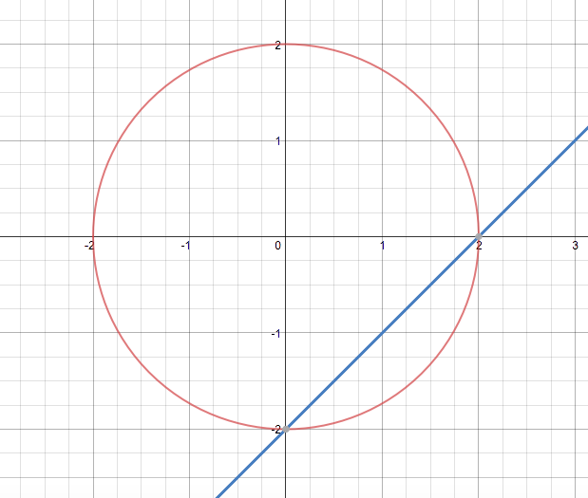

- Is the point (-1, 3) on the graph of the equation
$y= \left|x-2\right|$?

Show your work.

- The number of defects in a shipment of glass panes is represented by d = 0.1p, where d is the number of defect and p is the number of glass panes in the shipment.

If there are 200 glass panes in the shipment, how many defects will there be?

If the number of glass panes triples, how will that affect the number of defects in the shipment?

Is this a direct variation or an inverse variation?

- The equation rt = 1000 is the equation for how fast a 1000 gallon pool will drain, where r is the rate the water leaves the pool and t is the time it takes.

If the rate is 20 gallons per hour, how long will it take to drain the pool?

If the rate is tripled and the water drains three times as fast, what will happen to the time?

Is this a direct variation or an inverse variation?

