Unit 3 Probability Semester Review
- 0.5 B) 0.1 C) 0.333 D) 0.25
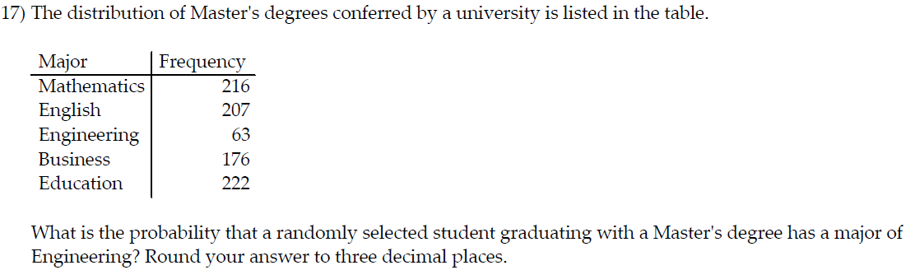
- 0.984 B) 0.071 C) 0.929 D) 0.016
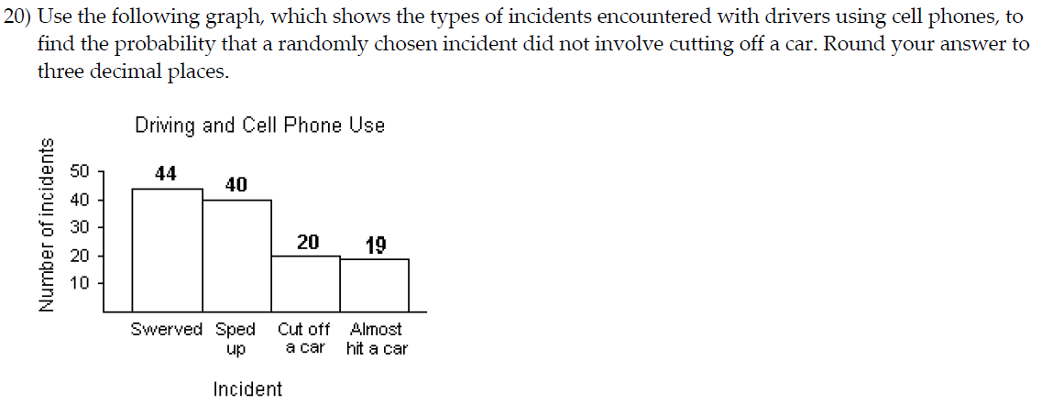
- 0.162 B) 0.200 C) 0.194 D) 0.837
- 11 B) 9 C) 40 D) 20
- 300 B) 2700 C) 3000 D) 2999
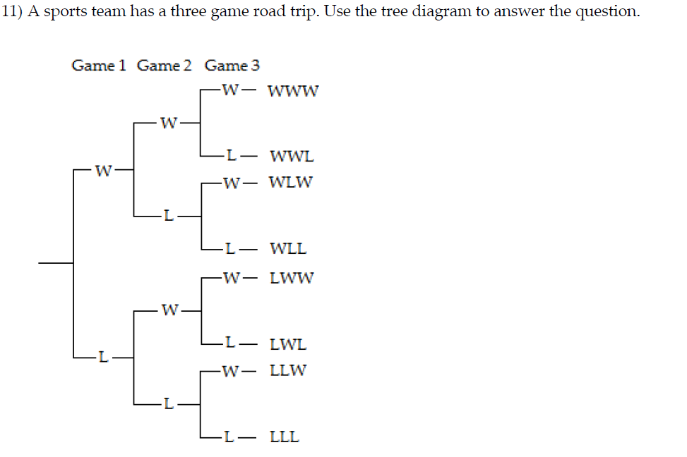
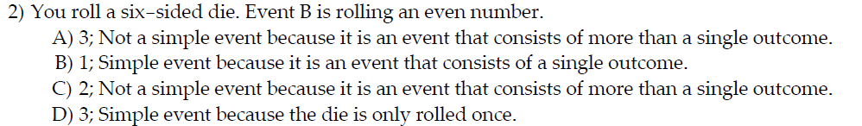
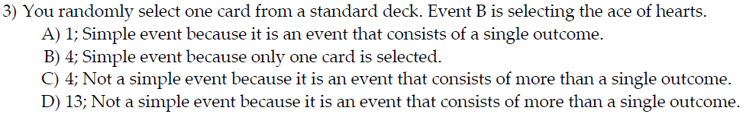

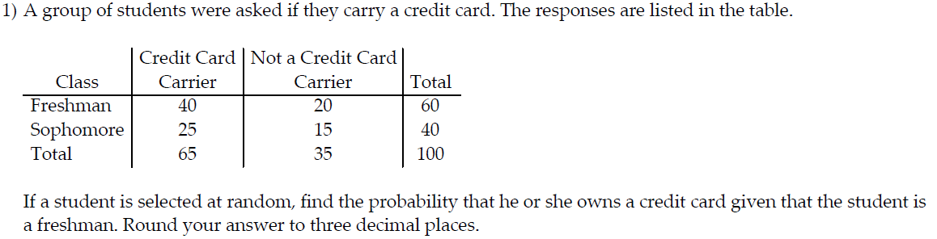
- 0.400 B) 0.615 C) 0.333 D) 0.667
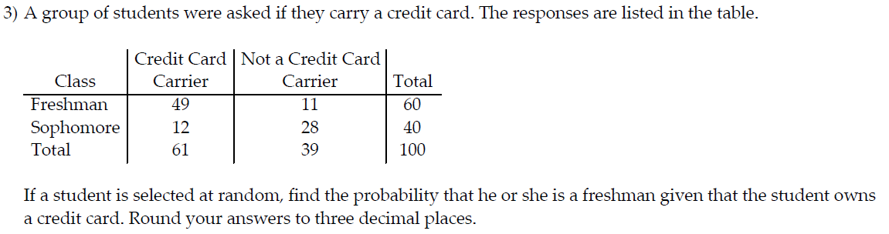
- 0.490 B) 0.197 C) 0.817 D) 0.803
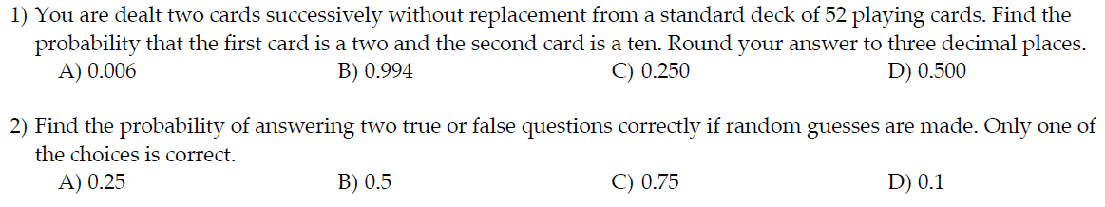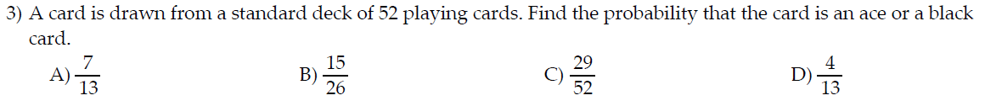
- 0.03 B) 0.2 C) 0.4 D) 0
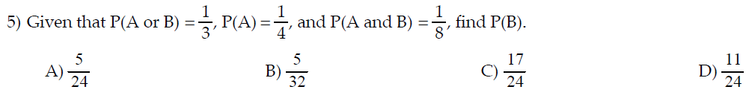
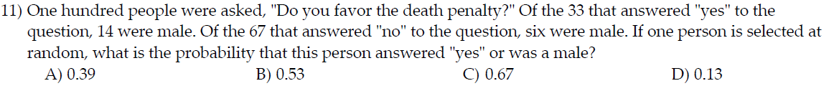
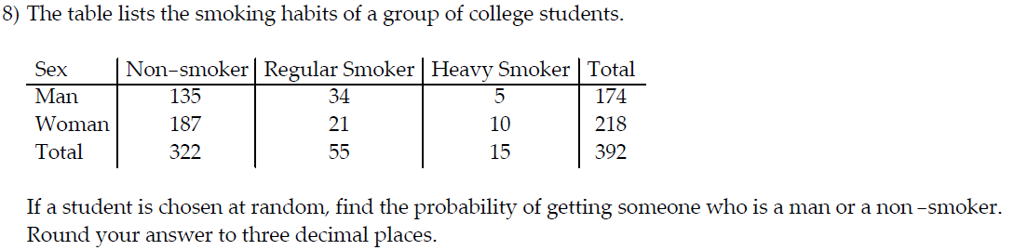
- 0.945 B) 0.921 C) 0.941 D) 0.860
In the Venn diagram below, event A represents the adults who drink coffee, event B represents the adults who drink tea, and event C represents the adults who drink cola.
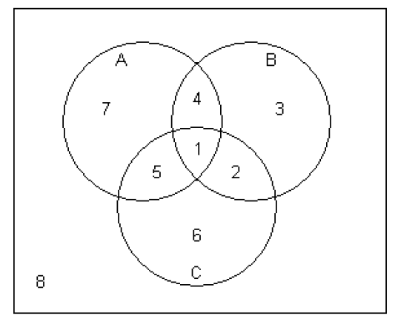
4) What is the probability that a randomly selected adult drinks coffee or cola?
A) 0.86 B) 0.69 C) 0.89 D) 0.22
- 126 B) 5 C) 362,880 D) 15,120

