Unit 4 Semester Review
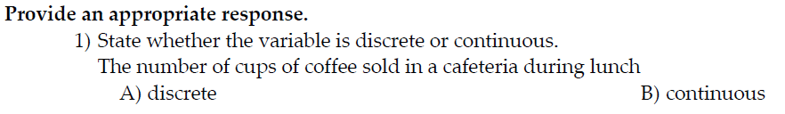
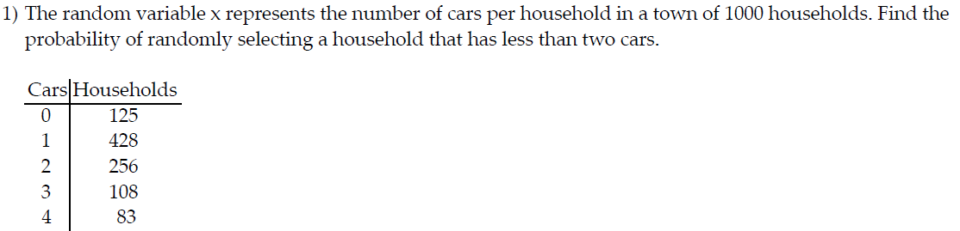
- 0.428 B) 0.125 C) 0.553 D) 0.809
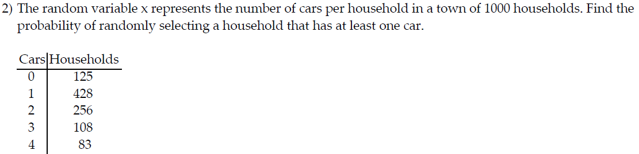
- 0.125 B) 0.500 C) 0.083 D) 0.875
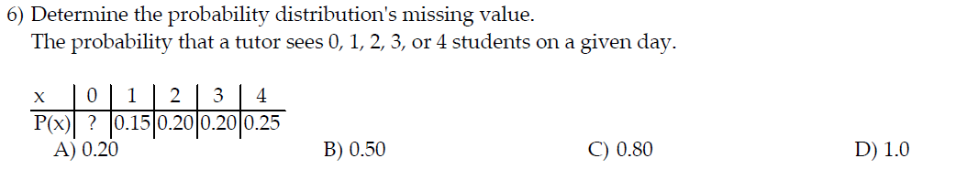
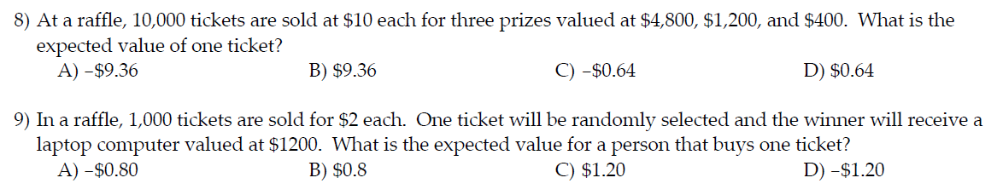

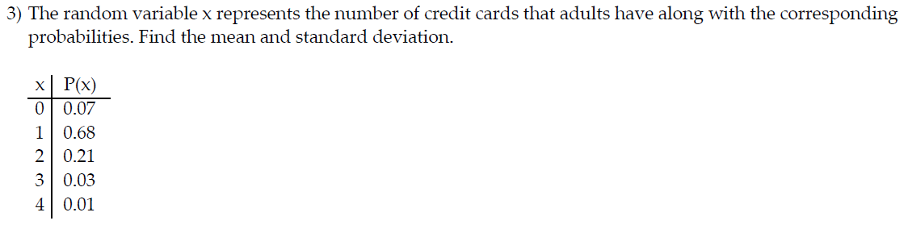
A) mean: 1.30; standard deviation: 0.44 B) mean: 1.23; standard deviation: 0.44
C) mean: 1.23: standard deviation: 0.66 D) mean: 1.30; standard deviation: 0.32
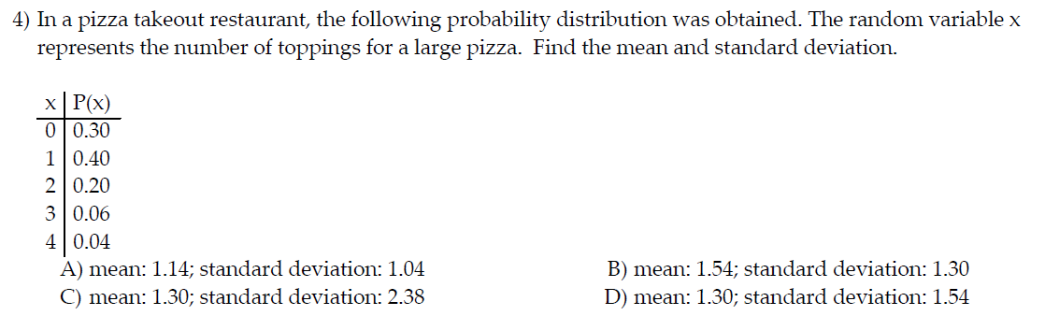
2) Find the variance of the binomial distribution for which n = 800 and p = 0.87.
A) 32.54 B) 90.48 C) 9.51 D) 696
6) In a recent survey, 80% of the community favored building a police station in their neighborhood. If 15 citizens are chosen, what is the mean number favoring the substation?
A) 10 B) 12 C) 15 D) 8
A) mean: 10; standard deviation: 1.26 B) mean: 1.6; standard deviation: 1.26
C) mean: 10: standard deviation: 1.16 D) mean: 1.6; standard deviation: 1.16
- 0.058 B) 0.571 C) 0.640 D) 0.184
- 0.0144 B) 0.50 C) 0.1056 D) 0.7744
- 8100 B) 90 C) 0.123456789 D)

